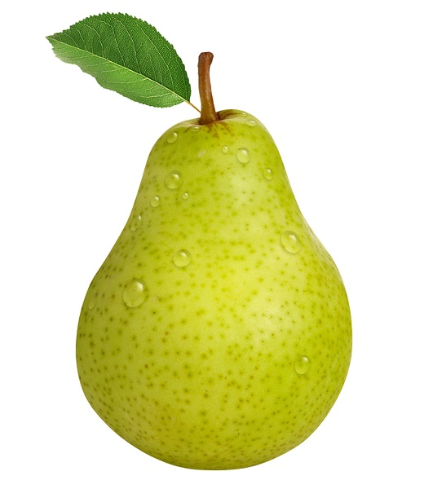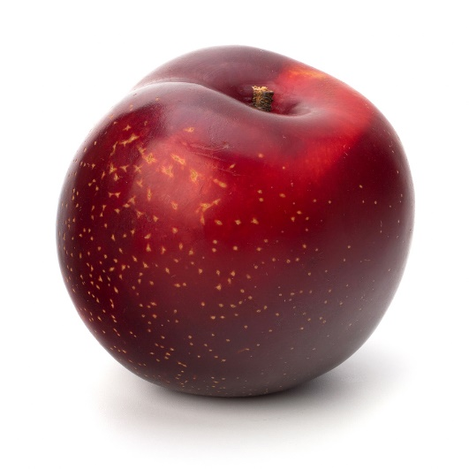

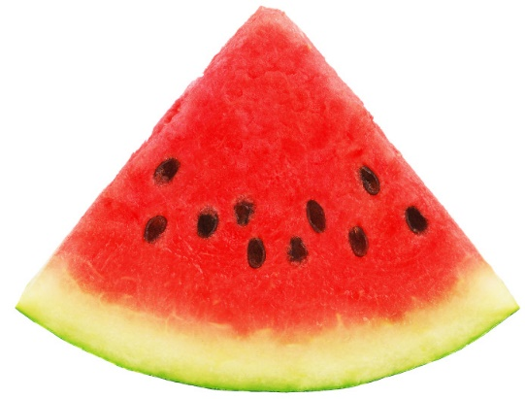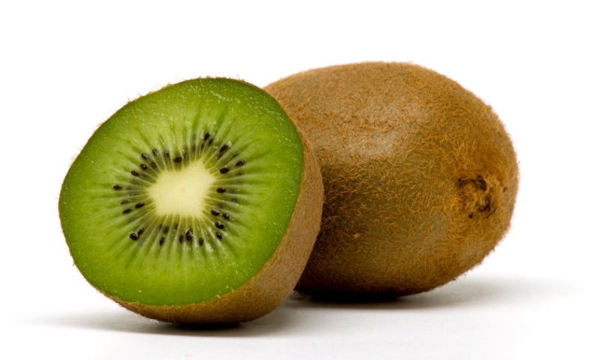

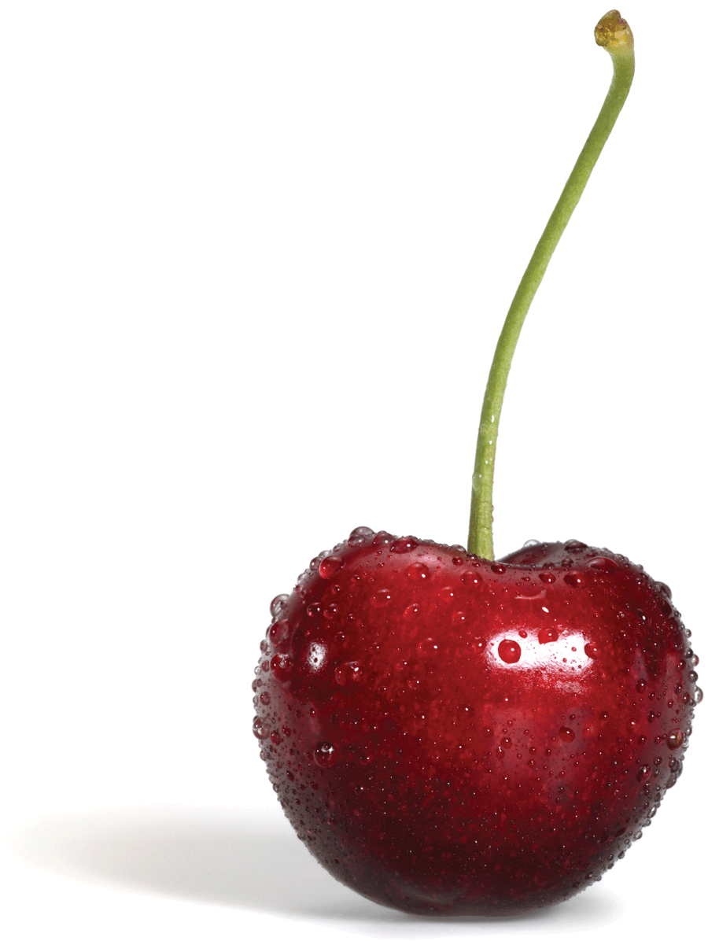

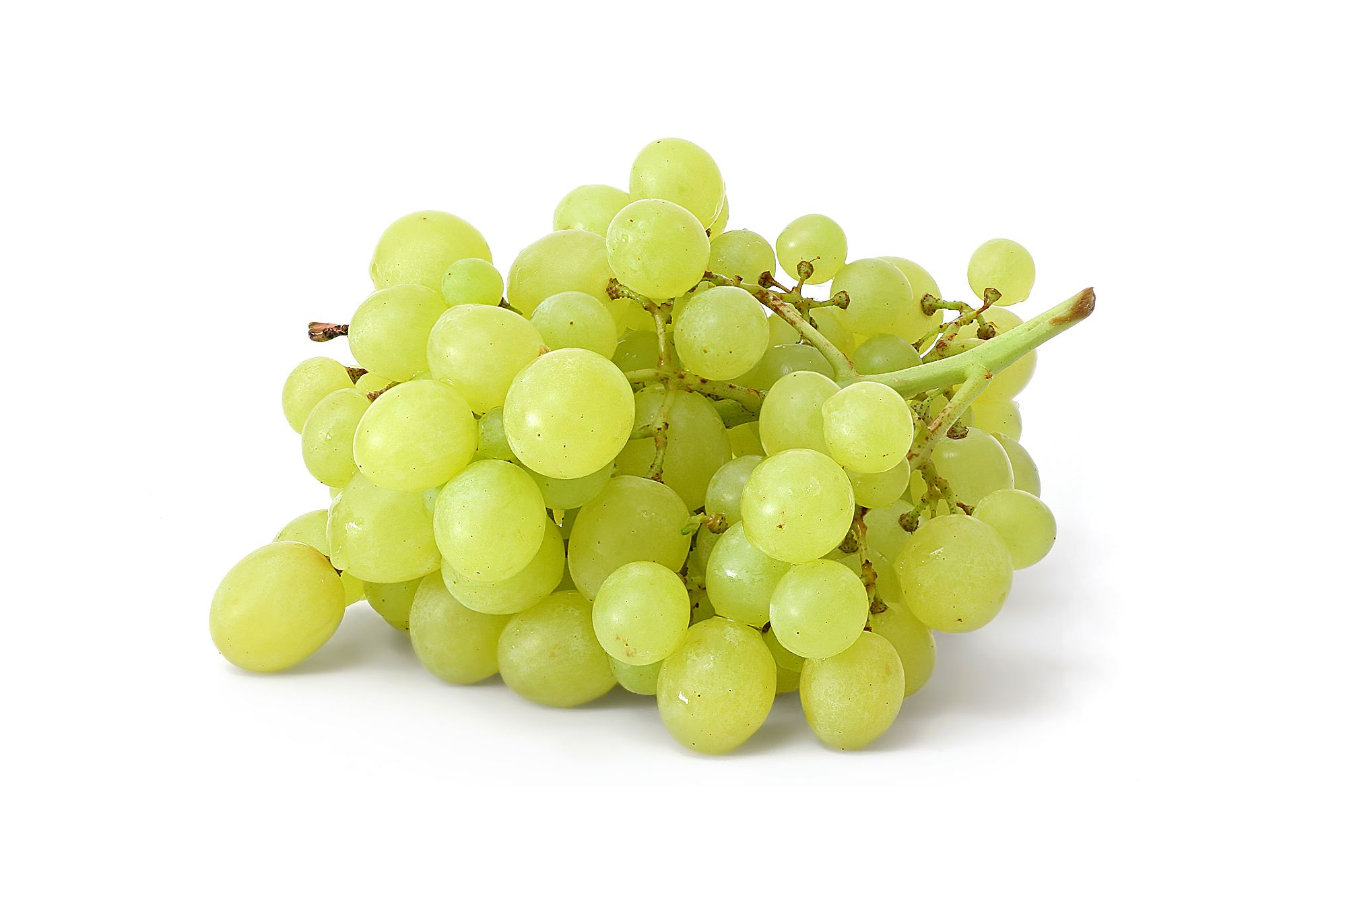

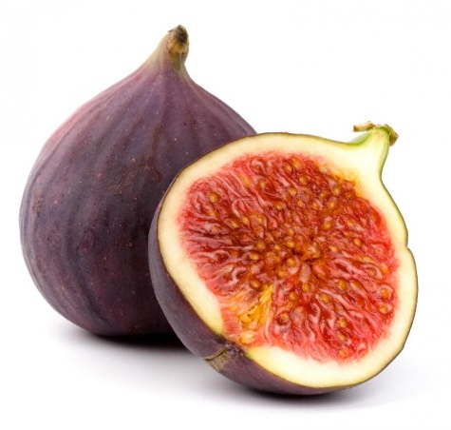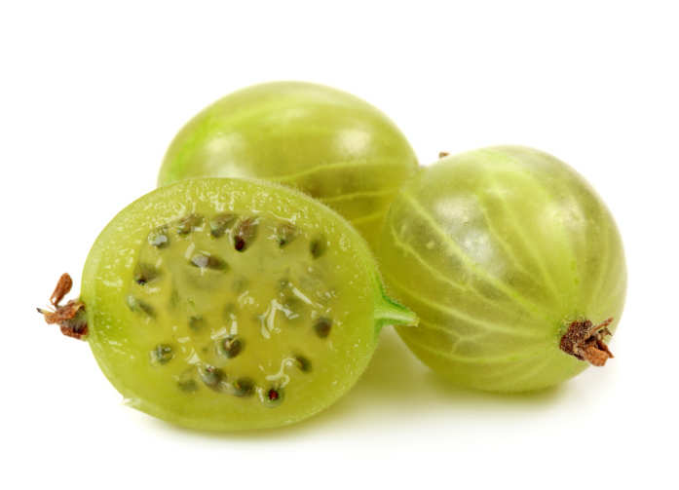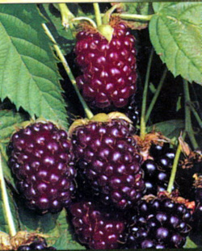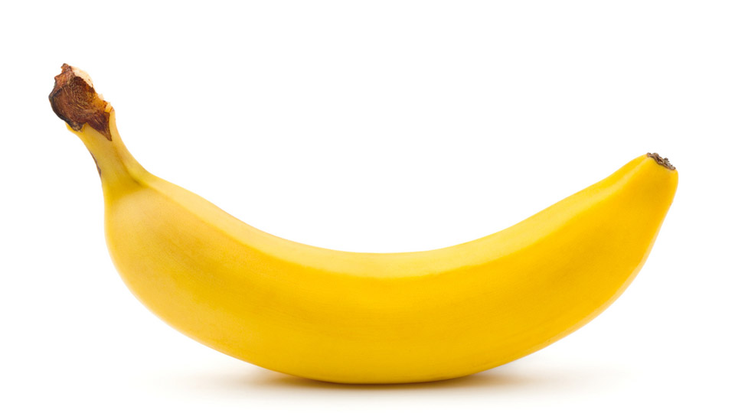 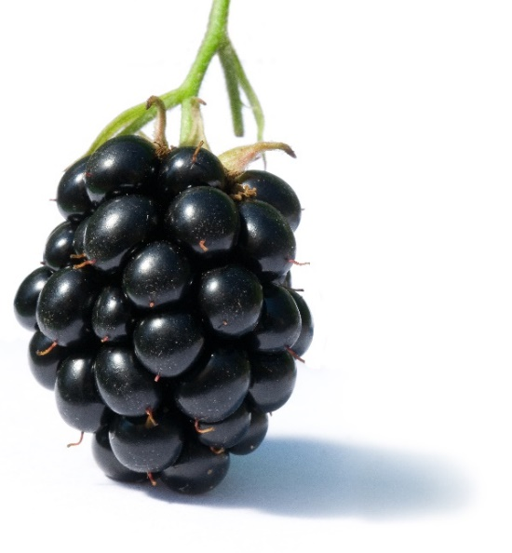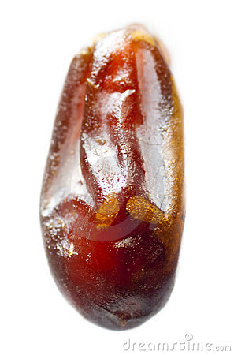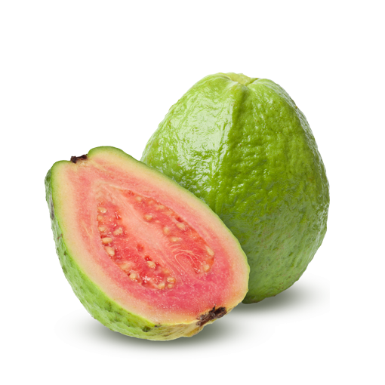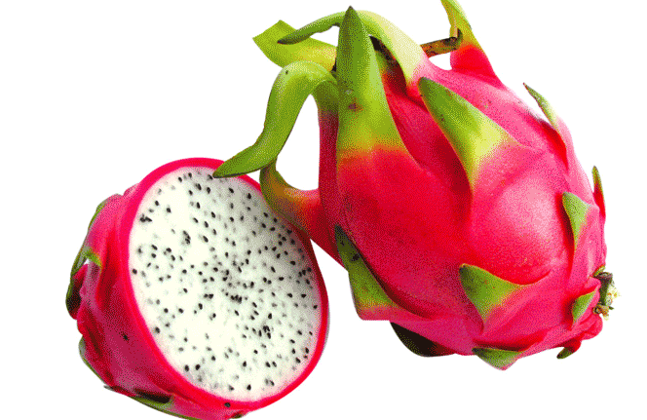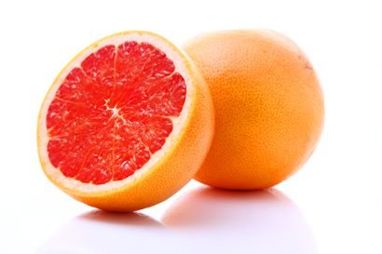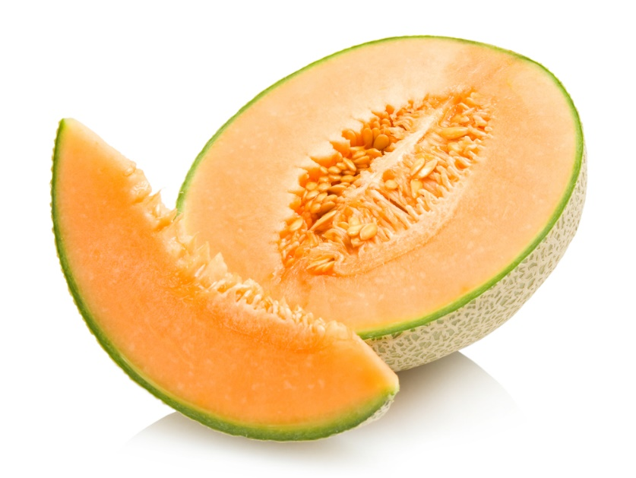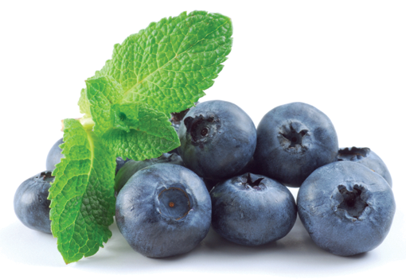

Boysenberry

Date

Fig

Blackberry

Chinese Gooseberry

Guava

Dragonfruit

Cantaloupe

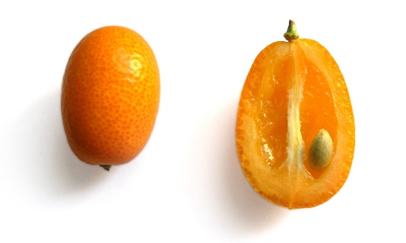

Kumquat

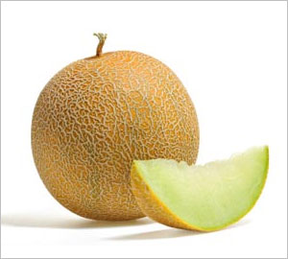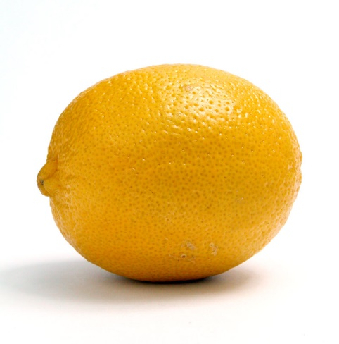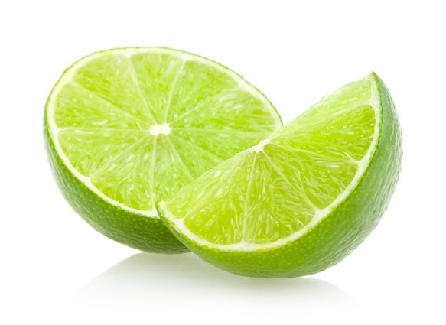

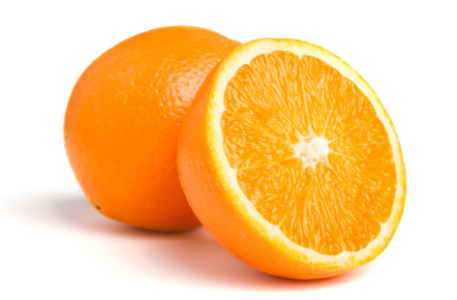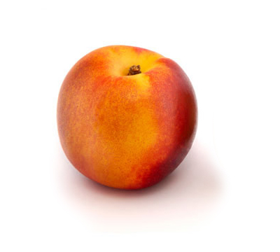

Honeydew

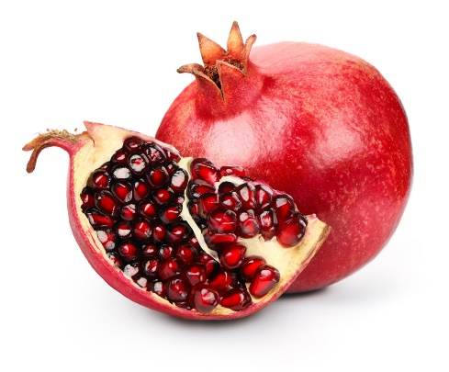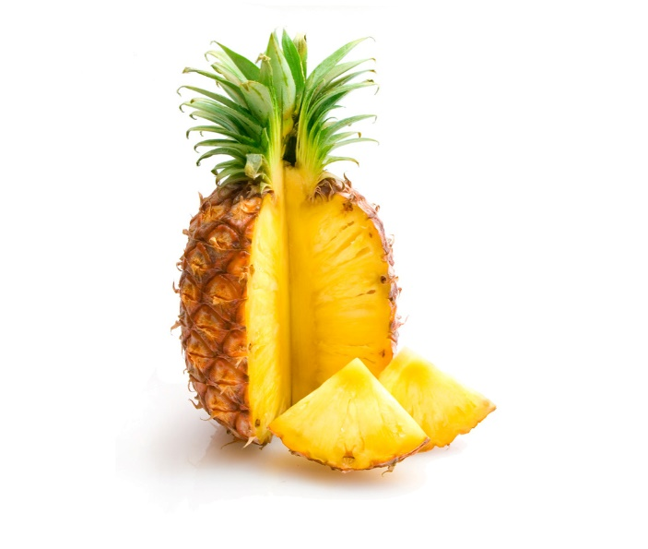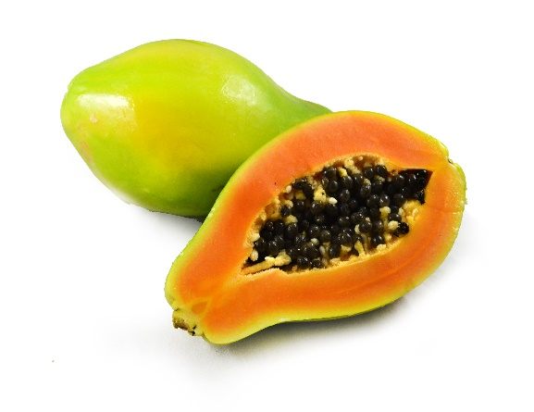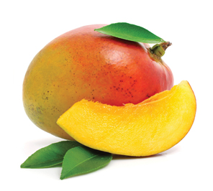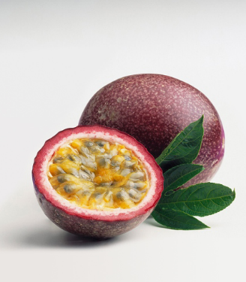

Nectarine

Pomegranate

Papaya

Passionfruit

Mango

What the diagram should look like:

Create a collage of the fruit pictures on a board so that each fruit you want students to identify can be seen. Write a number next to the fruits, and have students guess what each of the fruits are by number. An example of a started board is below. Worksheet is below; more numbers can be added if more fruits are added.

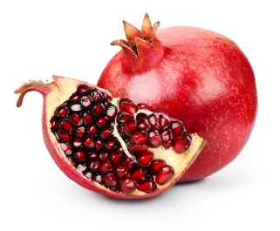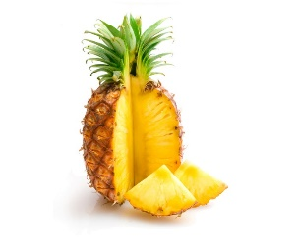

1.

2

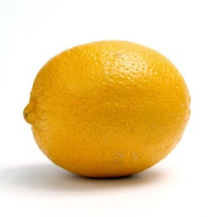

3

**Do you know your fruits?**

Try to name all the fruits you see! Name:___________________

1. __________________________________________________
2. __________________________________________________
3. __________________________________________________
4. __________________________________________________
5. __________________________________________________
6. __________________________________________________
7. __________________________________________________
8. __________________________________________________
9. __________________________________________________
10. ______________________________________________
11. ______________________________________________
12. ______________________________________________
13. ______________________________________________
14. ______________________________________________
15. ______________________________________________
16. ______________________________________________
17. ______________________________________________
18. ______________________________________________
19. ______________________________________________
20. ______________________________________________
21. ______________________________________________
22. ______________________________________________
23. ______________________________________________
24. ______________________________________________
25. ______________________________________________
26. ______________________________________________
27. ______________________________________________
28. ______________________________________________